Please join the Early Childhood Education Club at Quinsigamond Community College for a showing of the film

NO SMALL MATTER

Our future depends on our youngest citizens. On how many words they hear in their first months of life. On how often they are held. On the kinds of experiences they have.
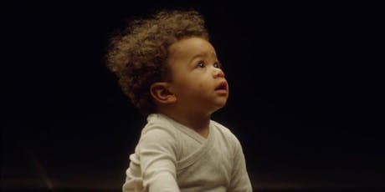
No Small Matter is a feature-length documentary film and national engagement campaign that brings public attention to the early childhood years by sharing powerful stories and stunning truths about the human capacity for early intelligence and the potential for quality early care and education to benefit America’s social and economic future. This multifaceted project reveals how our country is raising its youngest citizens, why making the most of this time in their lives is so crucial, and most importantly, what we can do to change the perception of when learning begins.
Thursday, November 14, 2019
6:30 PM -8:30 PM in the Hebert Auditorium
Quinigamond Community College
670 W. Boylston Street
Worcester, MA 01609
For more information or if you require accommodations to attend this event, contact Karen O’Neill, ECE Club Advisor, koneill@qcc.mass.edu or 508-854-2809.

