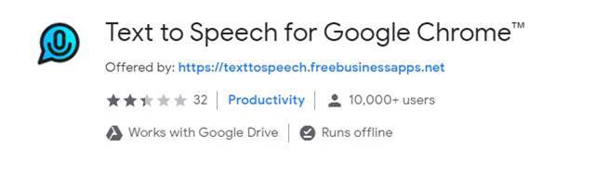

<https://chrome.google.com/webstore/detail/text-to-speech-for-google/ihjphbgdciilclbpcmagkacpohgokpep?hl=en-US>