[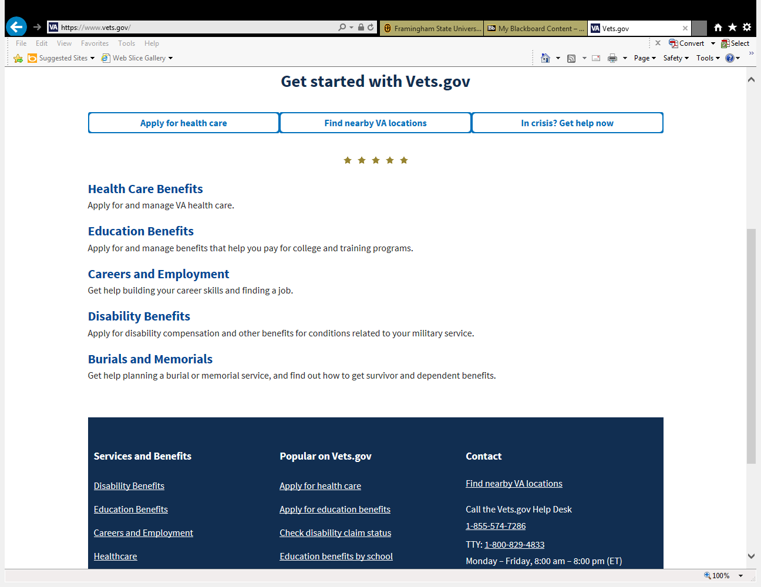](https://www.vets.gov/) [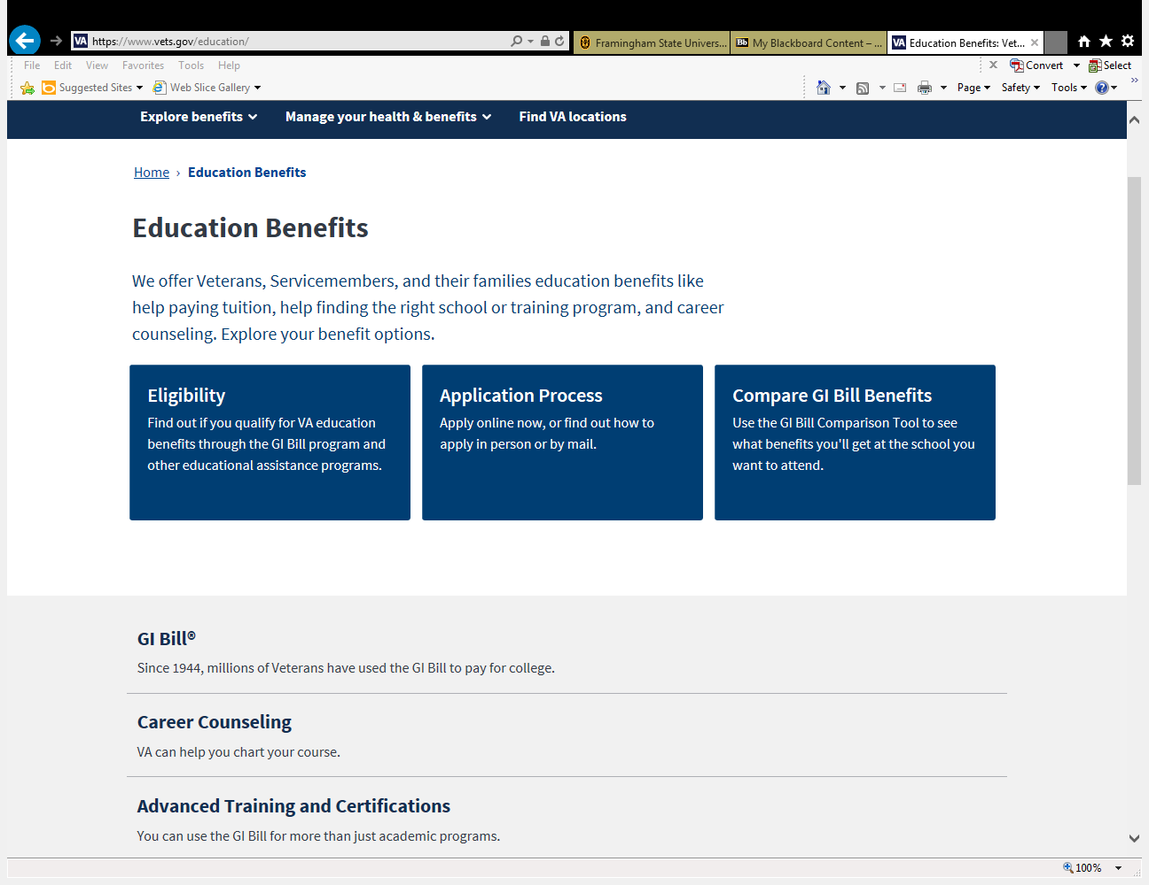](https://www.vets.gov/education/)

CLICK HERE

CLICK HERE

[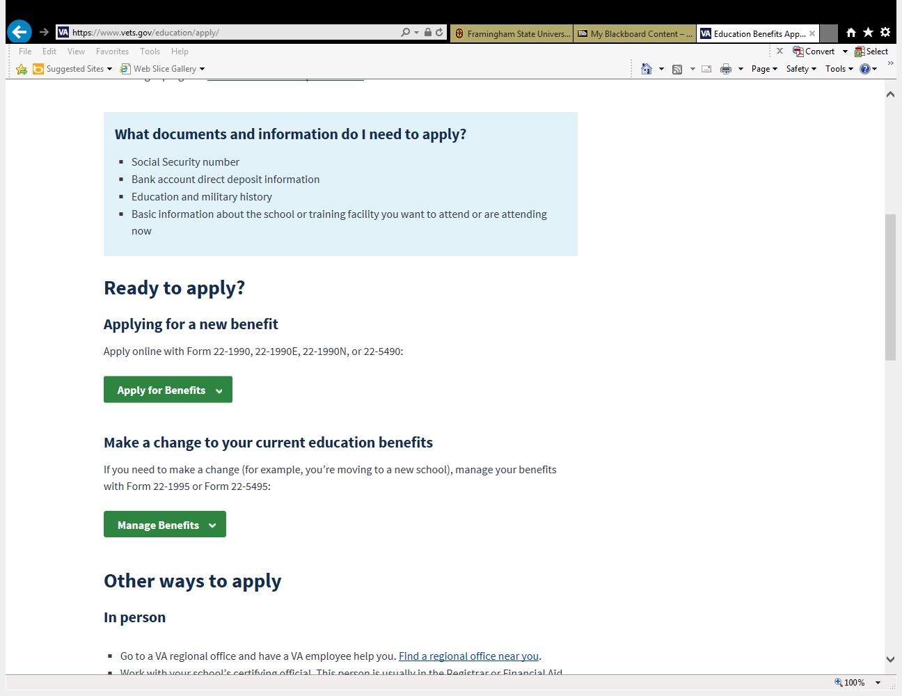](https://www.vets.gov/education/apply/) [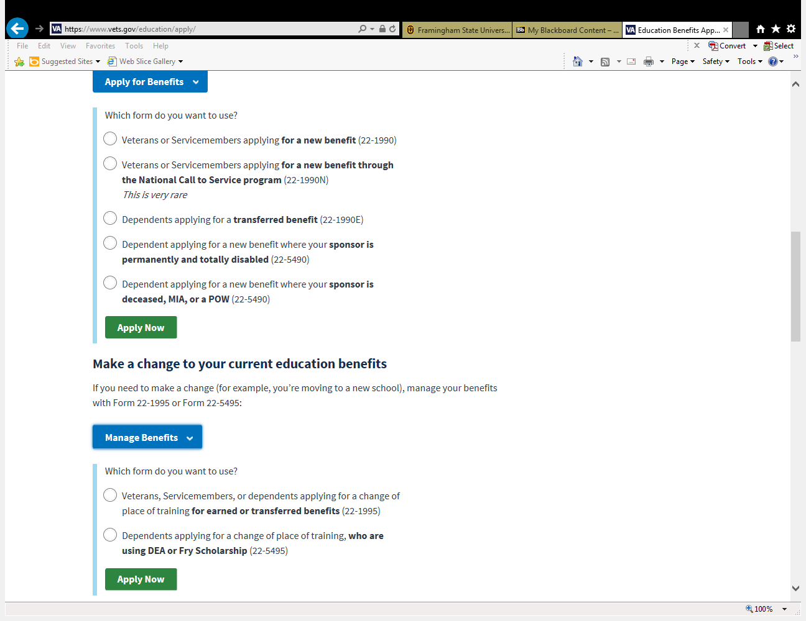](https://www.vets.gov/education/apply/)

CLICK HERE IF YOU ARE CHANGING YOUR SCHOOL OR PROGRAM (1995)

CLICK HERE IF YOU ARE STARTING YOUR GI BILL FOR THE FIRST TIME (1990)

CLICK HERE IF YOU ARE CHANGING YOUR SCHOOL (1995)

[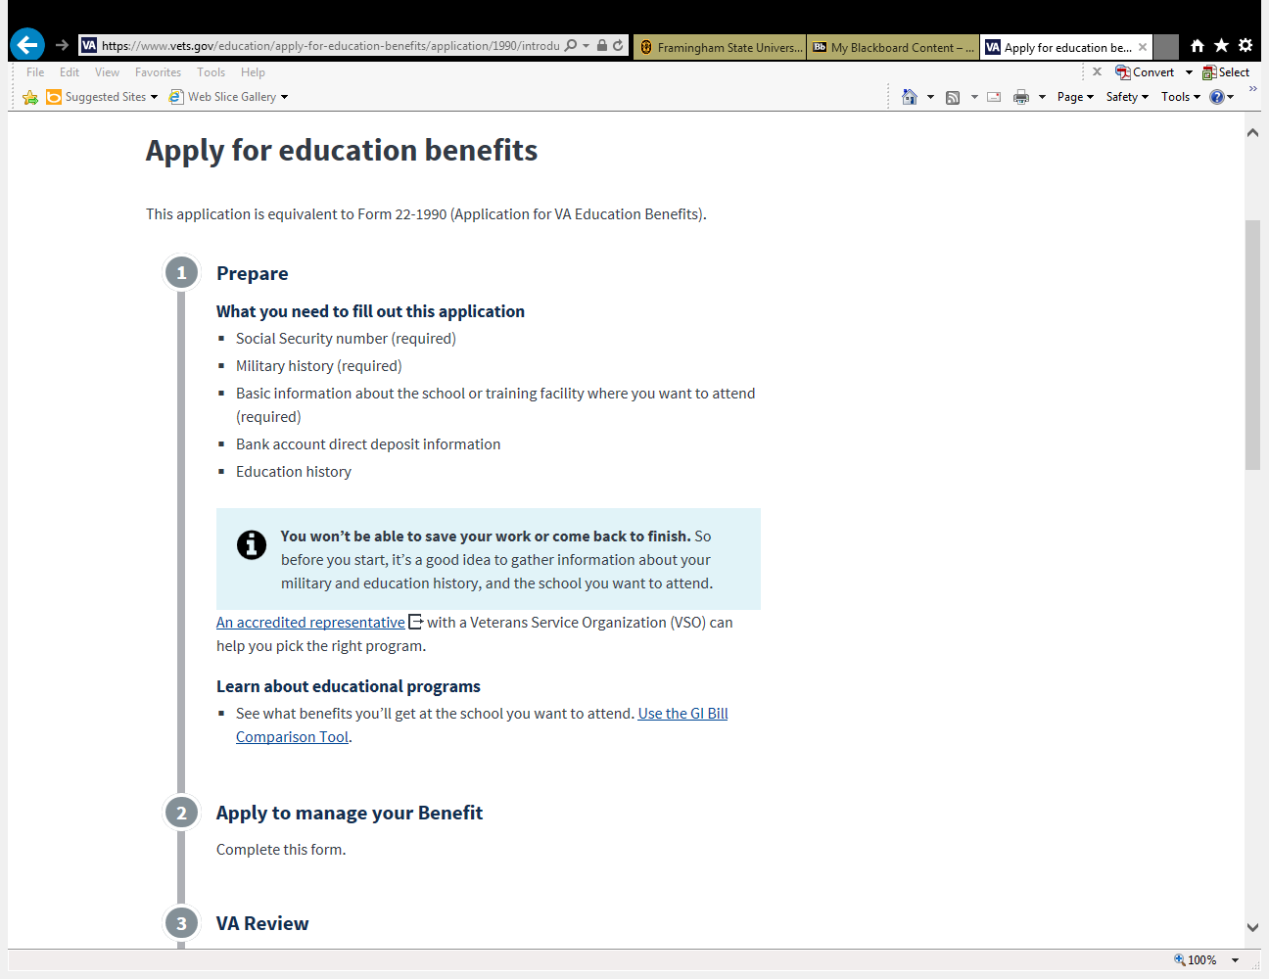](https://www.vets.gov/education/apply-for-education-benefits/application/1990/introduction) [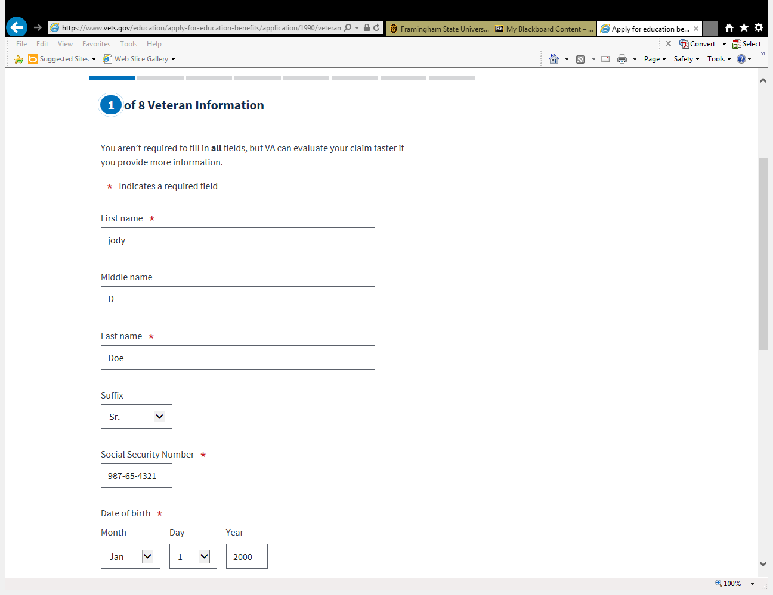](https://www.vets.gov/education/apply-for-education-benefits/application/1990/veteran-information)

SCROLL DOWN AND CLICK START APPLICATION

[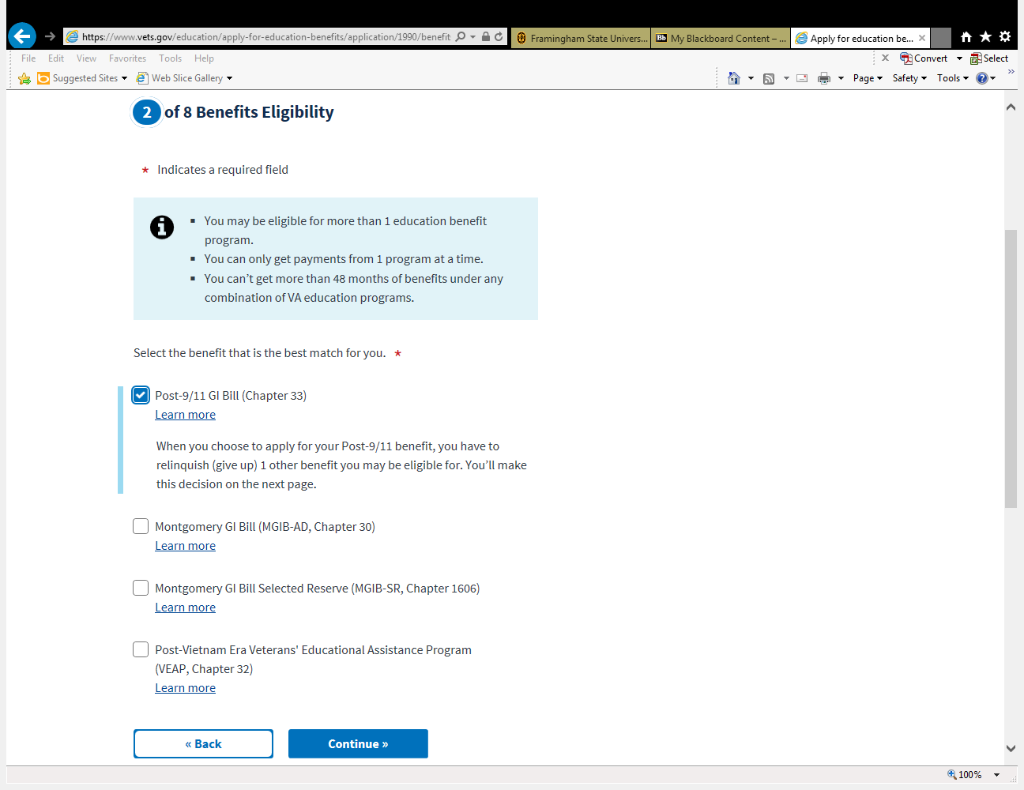](https://www.vets.gov/education/apply-for-education-benefits/application/1990/benefits-eligibility/benefits-selection) [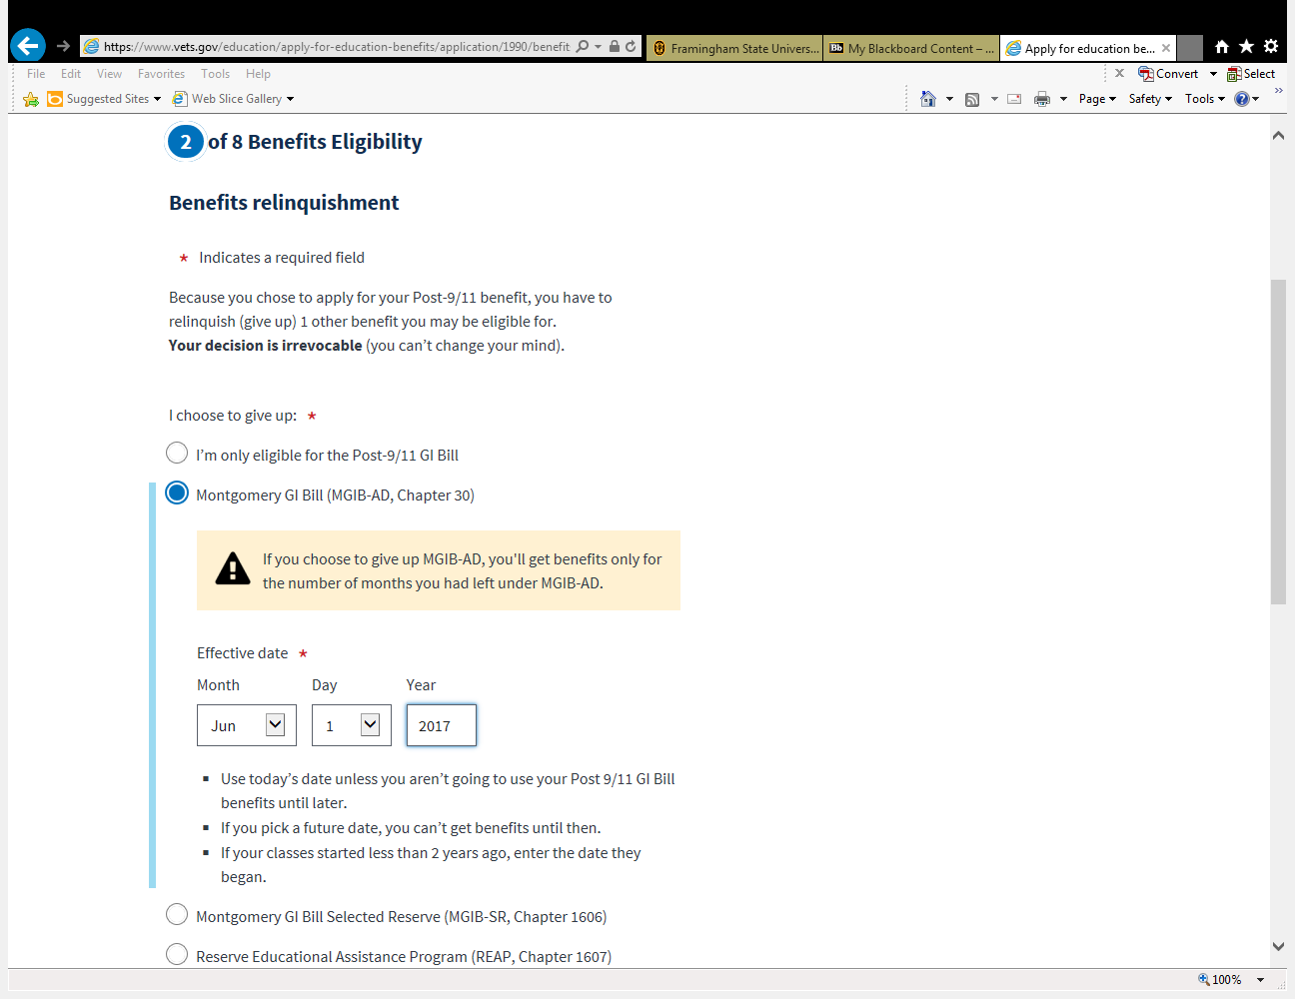](https://www.vets.gov/education/apply-for-education-benefits/application/1990/benefits-eligibility/benefits-relinquishment)

PUT TODAYS DATE

[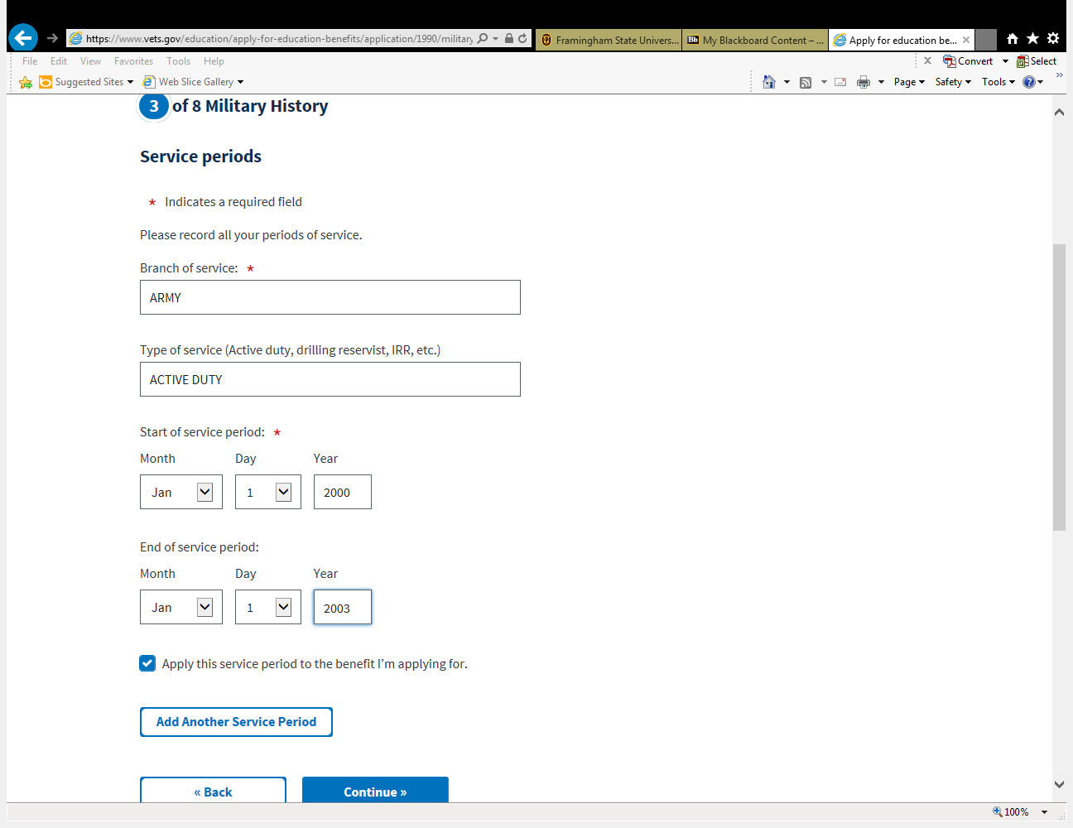](https://www.vets.gov/education/apply-for-education-benefits/application/1990/military-history/service-periods) [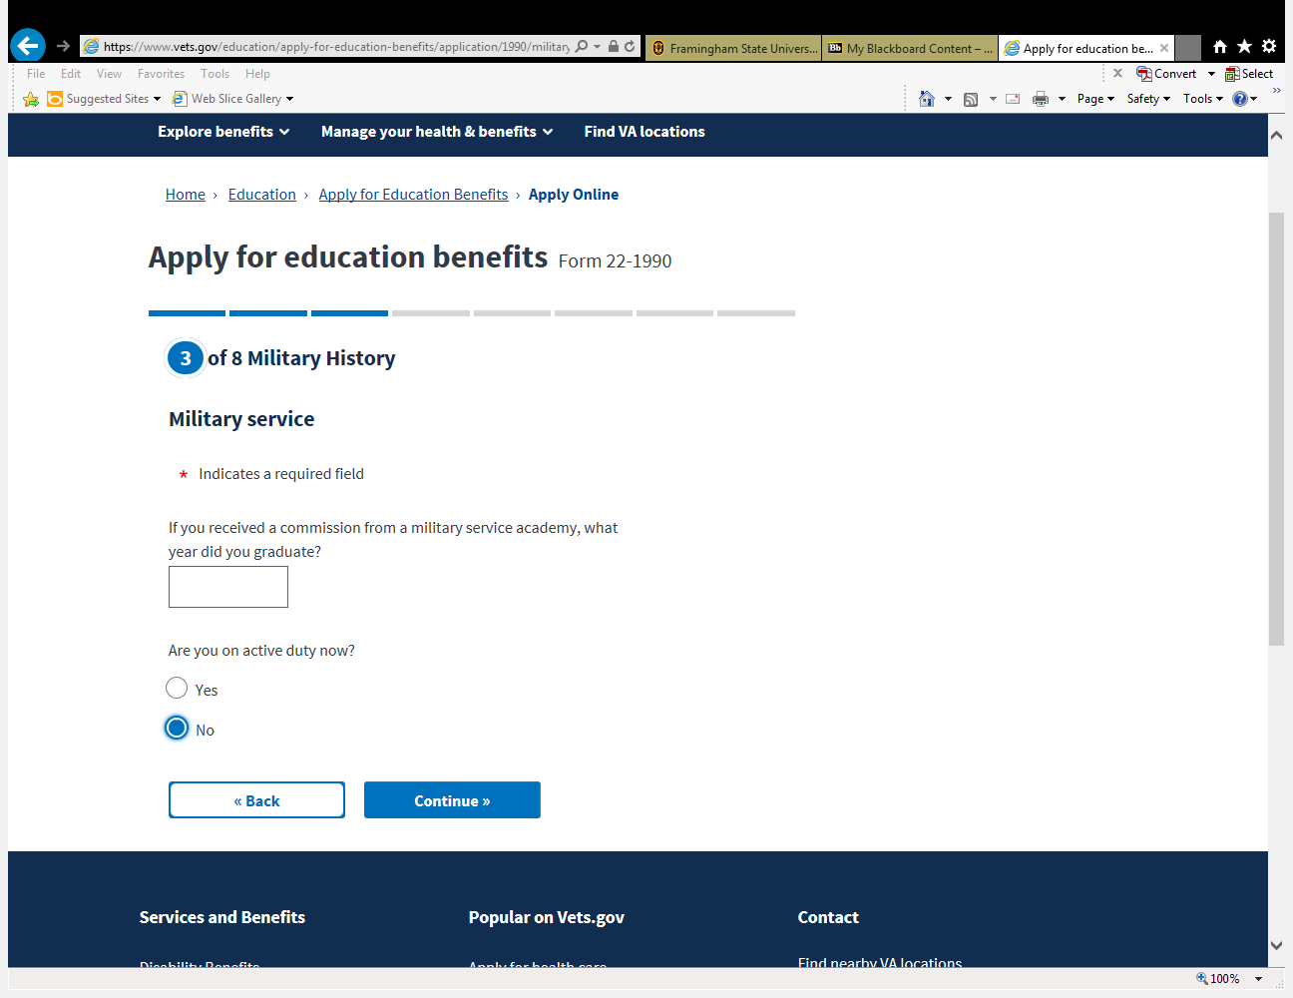](https://www.vets.gov/education/apply-for-education-benefits/application/1990/military-history/military-service)

DATE YOU STARTED YOUR MILITARY SERVICE

DATE YOU ENDED YOUR MILITARY SERVICE

[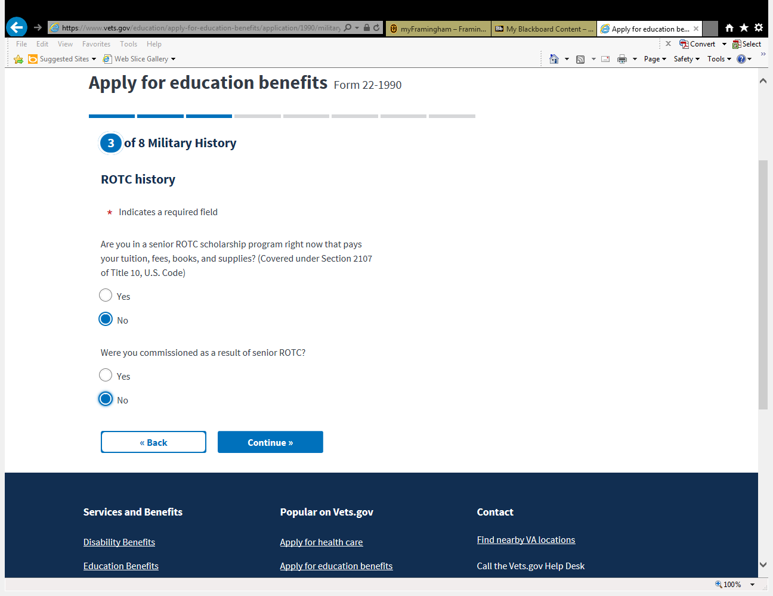](https://www.vets.gov/education/apply-for-education-benefits/application/1990/military-history/rotc-history) [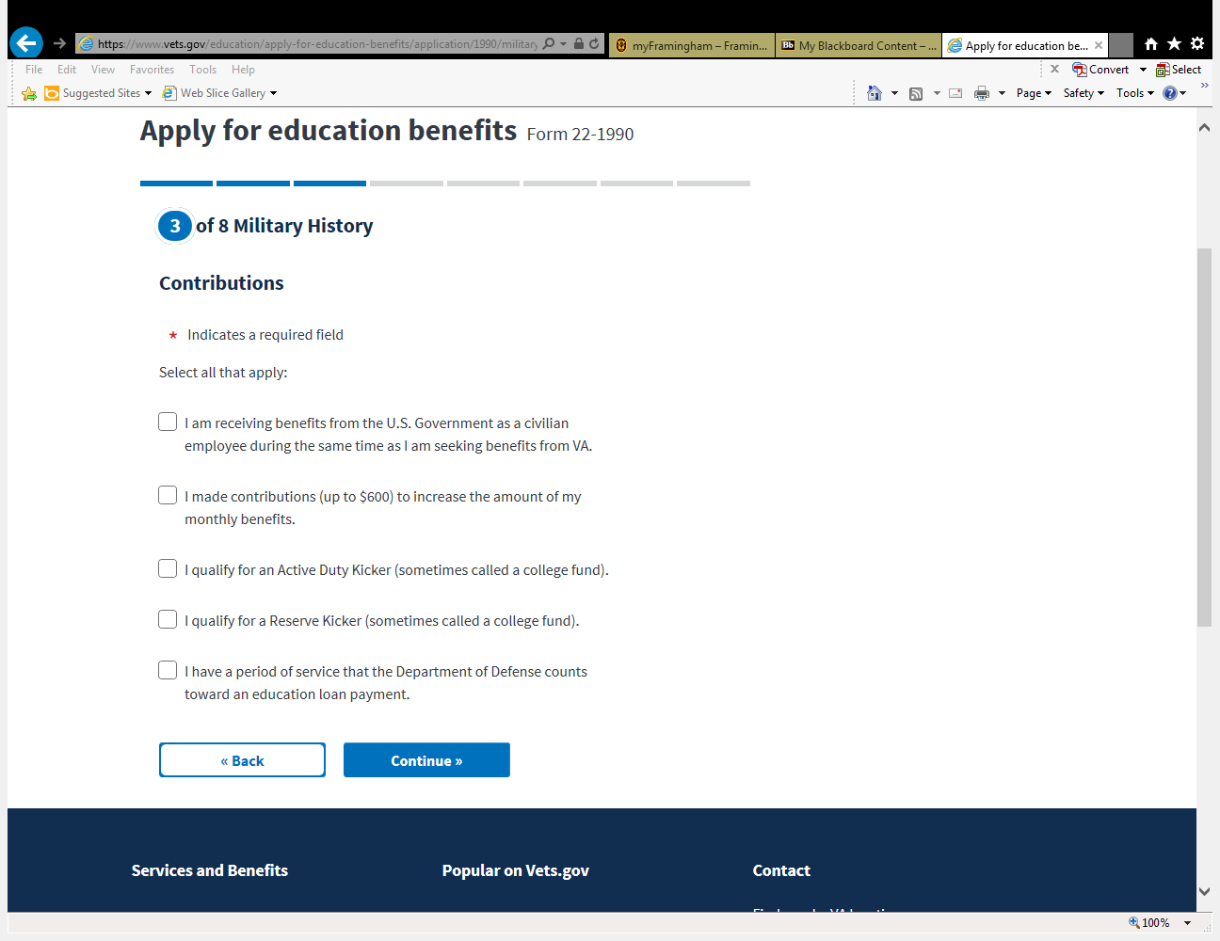](https://www.vets.gov/education/apply-for-education-benefits/application/1990/military-history/contributions)

[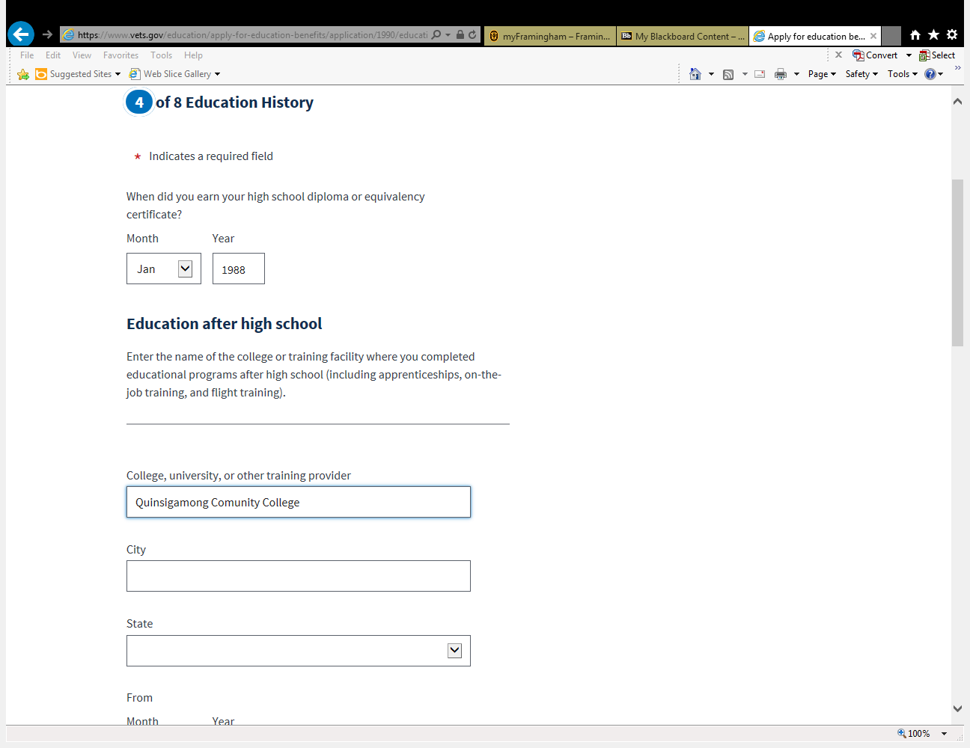](https://www.vets.gov/education/apply-for-education-benefits/application/1990/education-history/education-information) [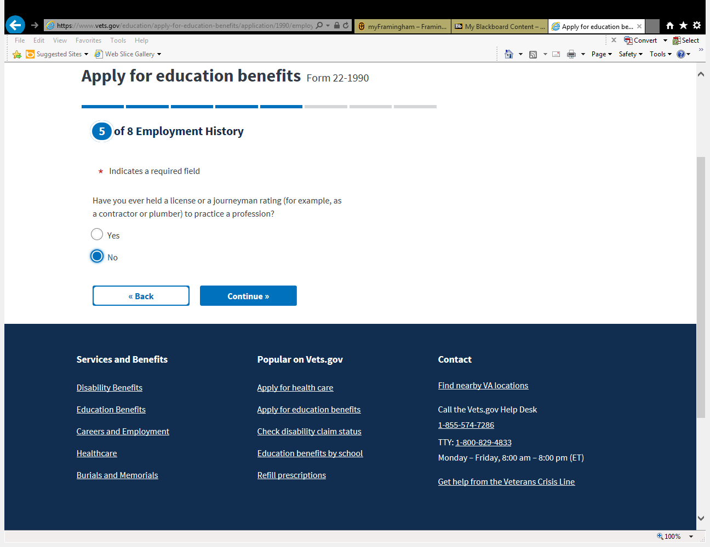](https://www.vets.gov/education/apply-for-education-benefits/application/1990/employment-history/employment-information)

[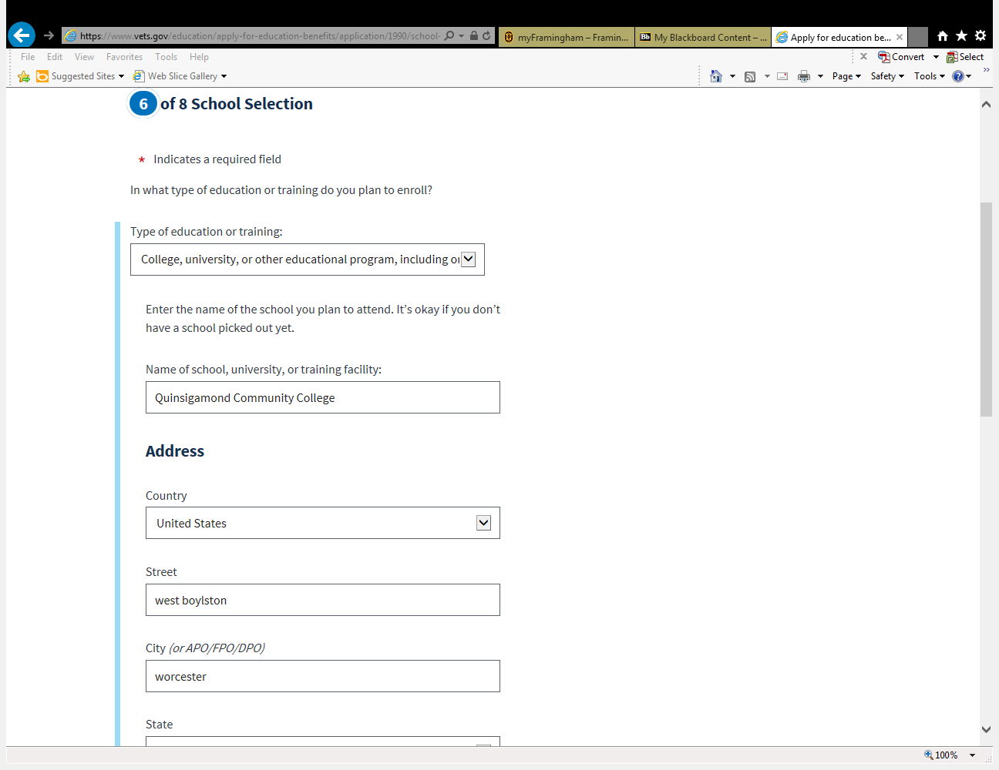](https://www.vets.gov/education/apply-for-education-benefits/application/1990/school-selection/school-information) [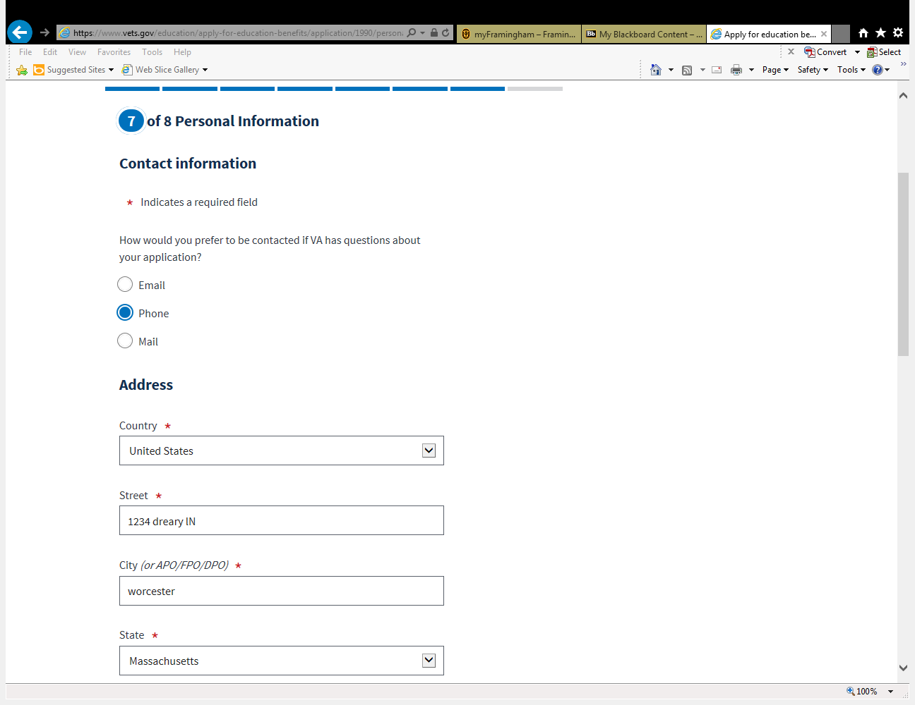](https://www.vets.gov/education/apply-for-education-benefits/application/1990/personal-information/contact-information)

[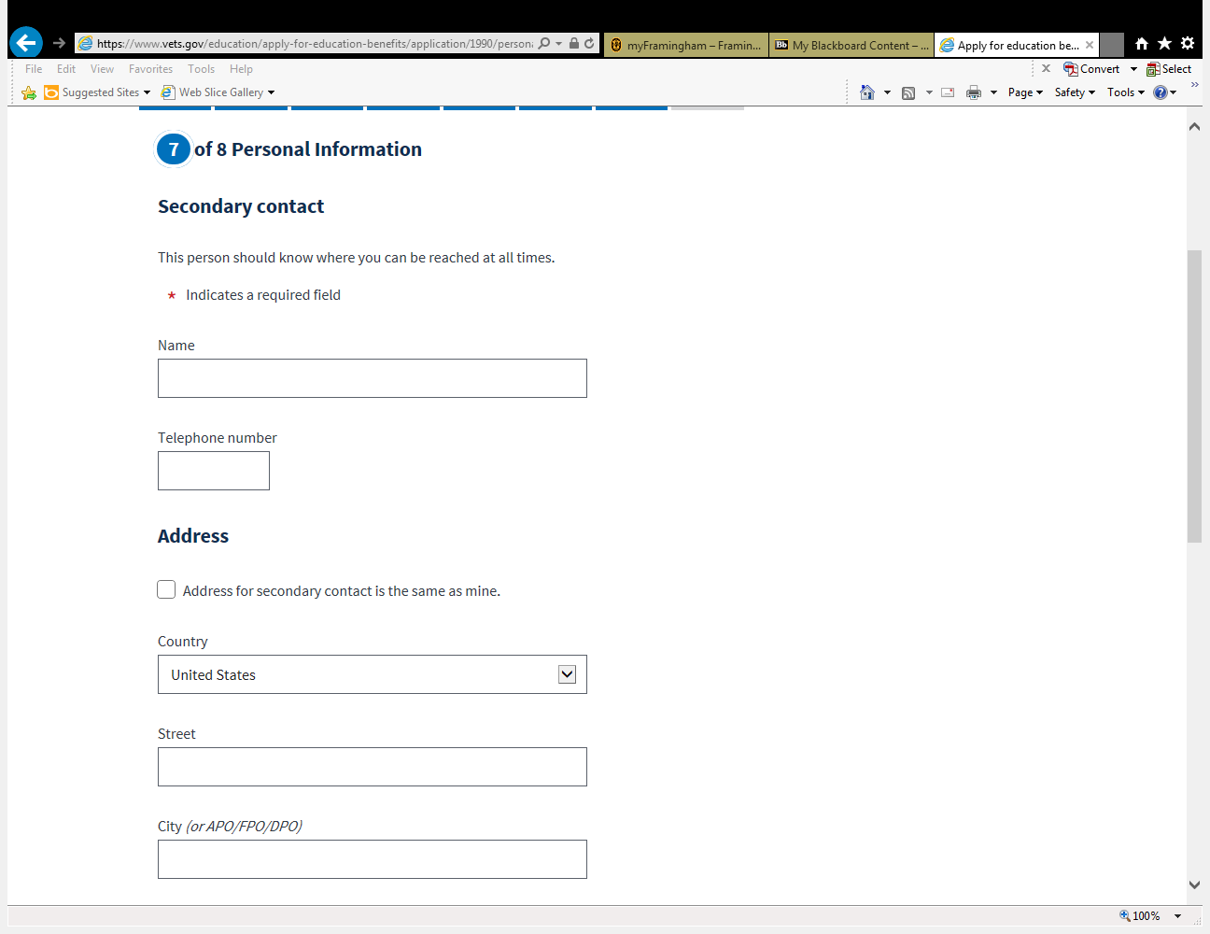](https://www.vets.gov/education/apply-for-education-benefits/application/1990/personal-information/secondary-contact) 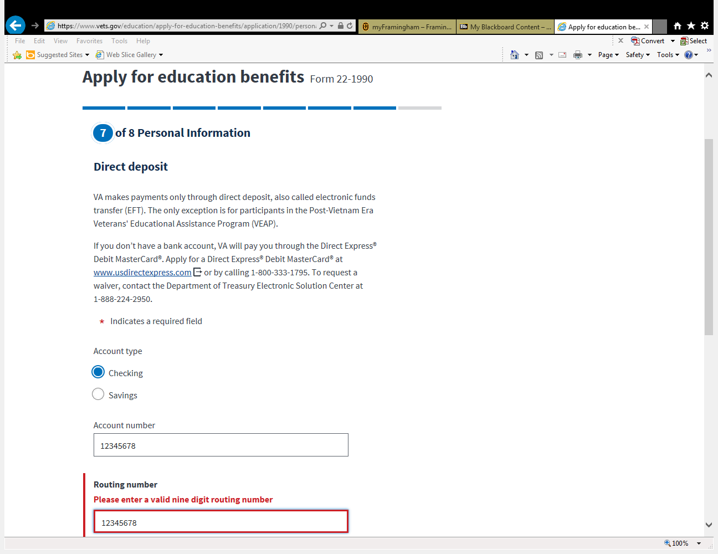

[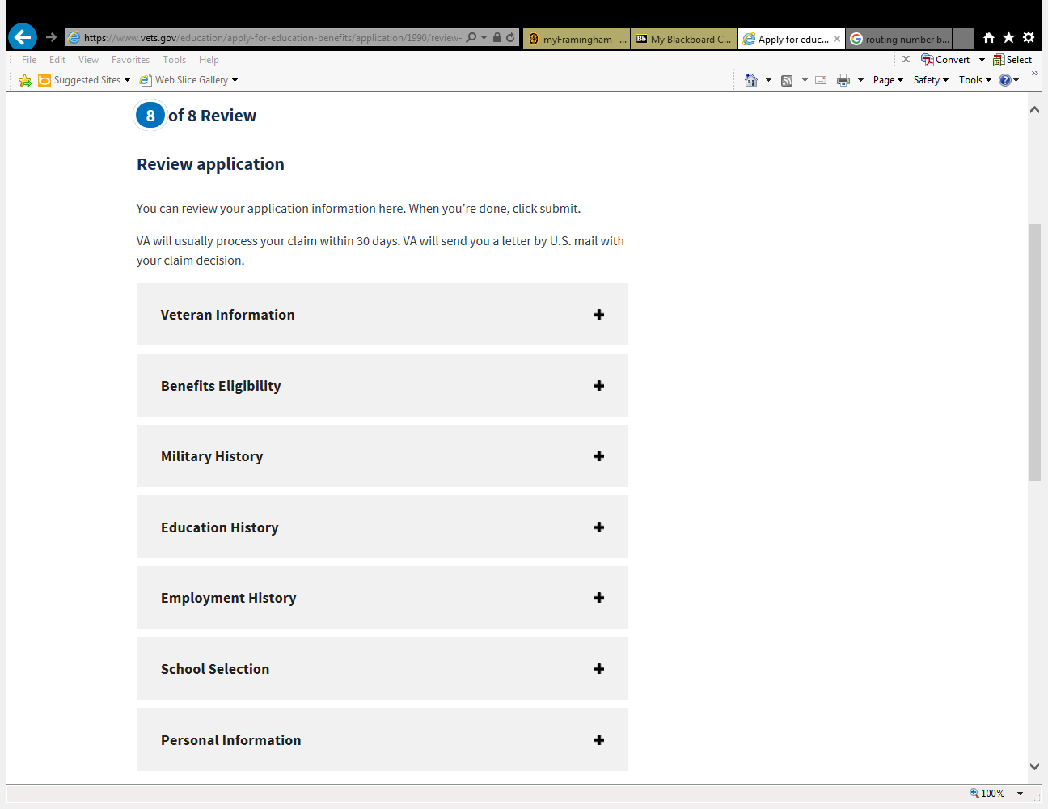](https://www.vets.gov/education/apply-for-education-benefits/application/1990/review-and-submit)