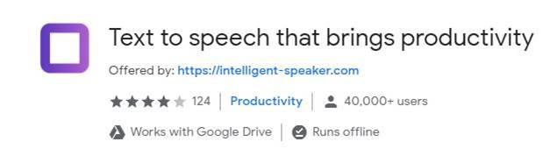

<https://chrome.google.com/webstore/detail/text-to-speech-that-bring/eidcpcpmmfiolomceegcagooodnaplmp?hl=en>