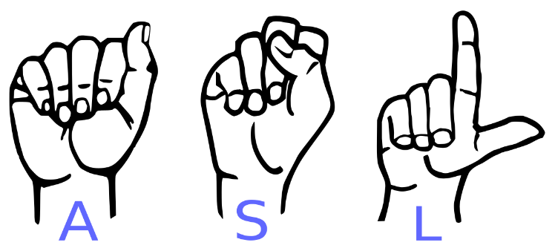

Qcc ASL Club

Hello everyone! I am pleased to tell you that QCC will have an American Sign Language Club.
- Are you interested to learn sign language?
- Thinking about being an interpreter?
- Want to improve your sign skills?
Come join us and learn more about ASL.
If interested, please contact:
Kim Cummings - kcummings@qcc.mass.edu
Or
Bianca Hoffmeister - bhoffmeister@qmail.qcc.edu

