QCC TRANSFER SERVICES
September 2019 Transfer Visits

All visits in the HLC Lobby, 10 a.m. – 1 p.m., unless noted otherwise.

September 10 September 23
Becker 10 a.m. - 2 p.m.

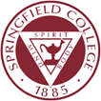
Colleges of Springfield Area September 24
September 11 10 a.m. - 2 p.m.

September 12 September 25
10:30 a.m. – 1:30 p.m.

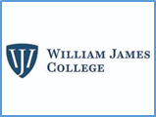
September 17 September 26
William James 10 a.m. - 2 p.m. Table 10 a.m. - 12 p.m.
Worcester SU 9:30 a.m. – 12:30 p.m. Appointments 12 - 3 p.m.

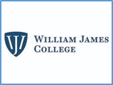
September 19 September 30
10:30 a.m. – 1:30 p.m. Bryant 10:30 a.m. – 1:30 p.m.
William James 10 a.m. - 2 p.m.

QCC TRANSFER SERVICES
October 2019 Transfer Visits

All visits in the HLC Lobby,
10 a.m. – 1 p.m., unless noted otherwise.

October 2
Worcester SU 9:30 a.m. – 12:30 p.m.

October 2
Table 10 a.m. - 12 p.m.
Appointments 12 - 3 p.m.

October 3

October 7

October 15
Becker 10 a.m.-2 p.m.
Worcester SU 9:30 a.m. – 12:30 p.m.

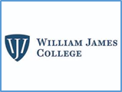
October 17
Bryant 10:30 a.m. – 1:30 p.m.

October 21

October 22

October 29
10 a.m.-2 p.m.

