Troubleshooting and Support for Microsoft Office 365 (M365)

If you require assistance with your Microsoft password, please review the below information:

  - If the default password does not work for your first time signing into Office 365,
OR
  - You can’t log into your Office 365 account and you didn’t set up recovery questions

Contact the IT Service Desk at 508-854-4427, press 1 and then 1. Ask to have your Office 365 password reset. Phone support is offered 24 x 7. Drop-in support is offered on site at AB67 (the ramp at the back of the Administration Building)
Regular Hours: Monday – Friday 8am – 5pm (Closed weekends and holidays)
Summer Hours: Monday – Thursday 8am – 5pm, Friday 8am – noon (Closed weekends and holidays)

  - Once you receive your temporary password, follow the below steps:
- In your browser, go to www.office.com
- Select Sign in
- Enter your Qcc Microsoft email address (student@student.qcc.edu), then click Next
o At the page shown below, Select Work or School account

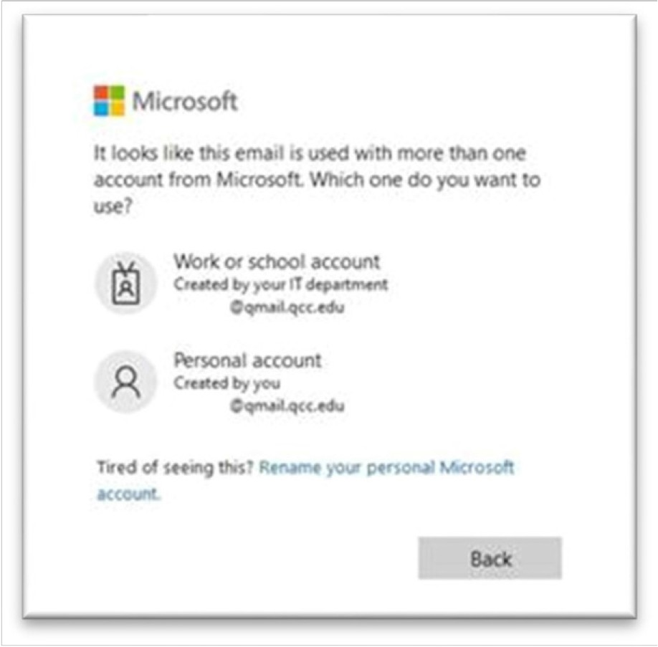

- Enter the password provided from support, then select Sign in
- A prompt for More information required appears, select Next. This will only take a few minutes. We strongly recommend you download and use the Microsoft Authenticator app and choose another method. Click on the text Set it up Now to the right of each item and follow the onscreen instructions.
    - Authentication Phone
    - Authentication Email (cannot be your student email)
- Security Questions (click to view tips on this step online)
- Once done, select finish button.
- You will then get a message asking if you’d like to stay signed in
  - If this is a personal device, select yes
  - If this is a public device, select no

- You may not be prompted to change the password; however, we strongly recommend that you do change your password.
  - On the top right side of the Microsoft office 365 home page, select the settings wheel .
  - Select the change password link
  - Enter your old password and then your new password then select Submit.
  - You will be redirected back to your Microsoft office 365 home page.

Additional help resources can be found at: Help | Quinsigamond Community College (QCC) (https://www.qcc.edu/help)

Online help for How-to and Troubleshooting Microsoft Office products is found by clicking on the ? icon next to your login avatar at the top right of the home page (This could be your initials or a picture).

